# Instructions for Instructors

## How to copy a testing agreement across different CRNs

1. [Log in to AEC Connect](https://aec.uoregon.edu/content/using-aec-connect) with your DuckID and password. This will take you to your Dashboard.
2. Click “Continue to View Student Accommodations”.

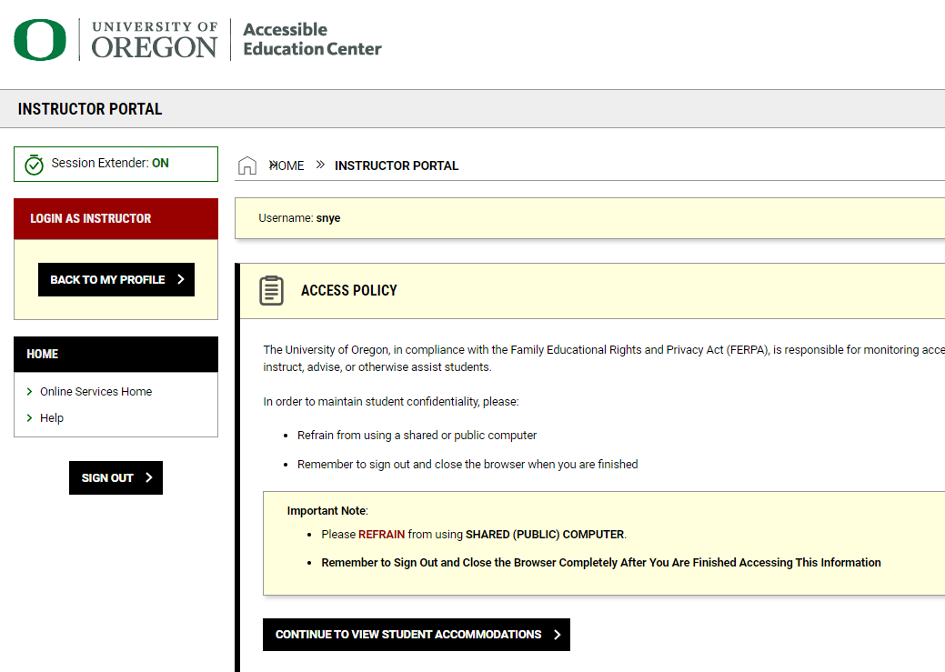

1. Next, click “Alternative Testing” on the left side of the screen.

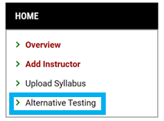 

1. Click “Testing Agreement” at the top right of the screen.

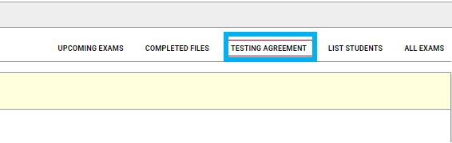 

1. Find the course with the testing agreement you want to copy and click “View/ Modify Testing Agreement”.

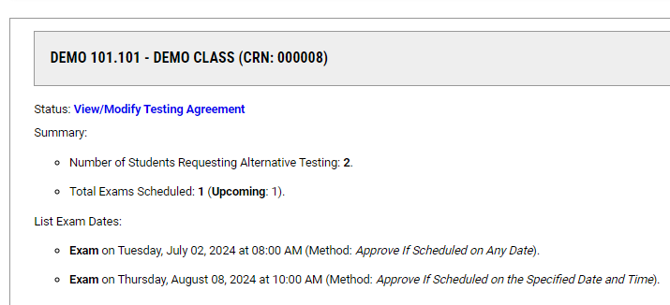

1. Click “Copy Testing Agreement” at the top of the screen.

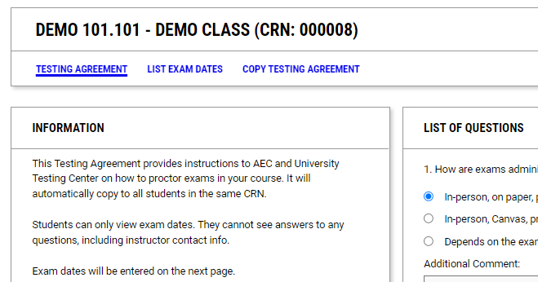

1. Find the box that says, “Copy Testing Agreement To” and select the course you would like to copy the testing agreement to. Then click “Continue”.

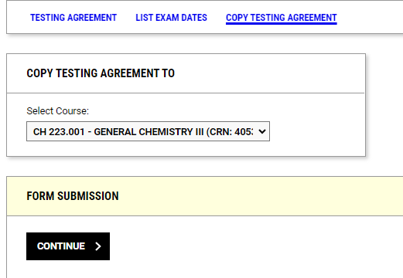

1. On the next screen, confirm the exam dates for the course and click “Copy Testing Agreement”.

