# Instructions for Instructors

## How approve an exam request is outside the parameters outlined in your Testing Agreement:

If you specify in your Testing Agreement that students must schedule exam requests on a certain day/time, you will receive an email any time a student submits a request outside those parameters. **AEC will never assume that it is okay to schedule an exam request contrary to your instructions.** Please respond to these emails as soon as possible to not hold up the exam scheduling process.

1. You will receive an email titled **“[AEC] ACTION NEEDED: Exam Request Outside Testing Agreement Parameters”.**
2. Open email and click “Review Exam Request”.

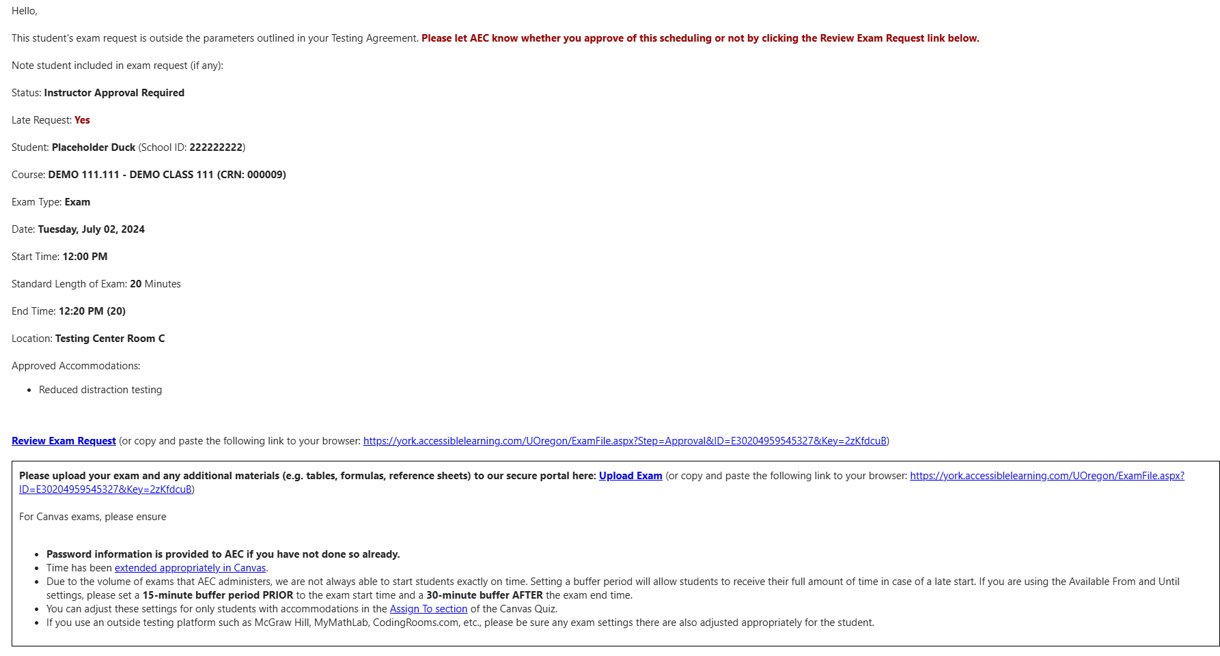

1. If you would like to approve the alternative time chosen by the student, click “Approve Exam Request”. If you would like the student to reschedule, click “Propose Rescheduling”.

