# Instructions for Instructors

## How to add a new instructor to a course:

**Accommodation information is strictly confidential. Only add those on a true need-to-know basis, such as a GE that administers exams for you.** Anyone added as an instructor will have access to student accommodation requests in that course, and will receive future notification letters and exam requests.

1. [Log in to AEC Connect](https://aec.uoregon.edu/content/using-aec-connect) with your DuckID and password. This will take you to your Dashboard.
2. Click “Continue to View Student Accommodations”.

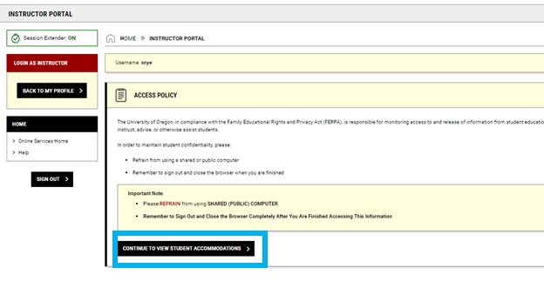

1. Next, click “Add Instructor” on the left side of the screen.

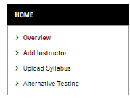

1. Select the class you would like to add an instructor to. Under “Type”, select the dropdown to add an additional instructor to the course or replace all instructors with the new instructor. Input the new instructor’s name and email address. Click “Add Instructor”.

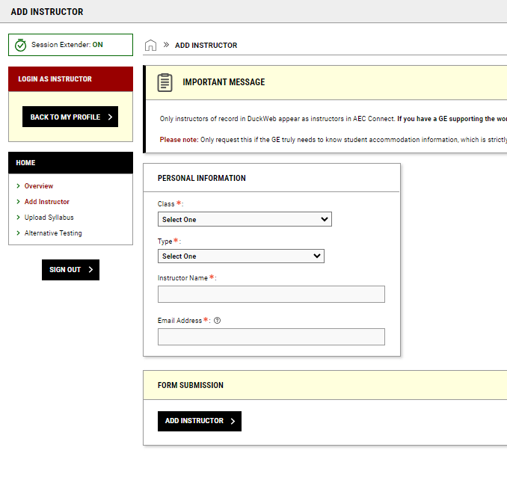

1. AEC receives requests to add instructors and will approve within 1-2 business days.