# Instructions for Instructors

## How to complete a testing agreement

1. [Log in to AEC Connect](https://aec.uoregon.edu/content/using-aec-connect) with your DuckID and password. This will take you to your Instructor Portal.
2. Click “Continue to View Student Accommodations”.

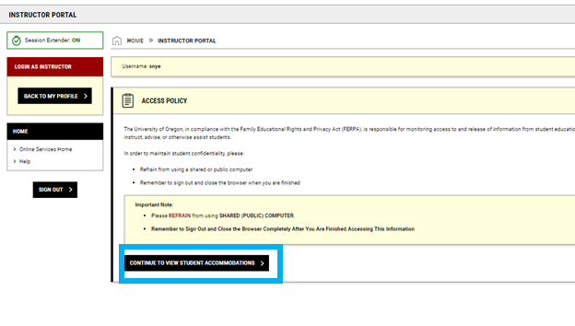

1. Next, click “Alternative Testing” on the left side of the screen.

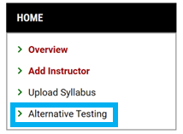

1. Click “Testing Agreement” at the top right of the screen.

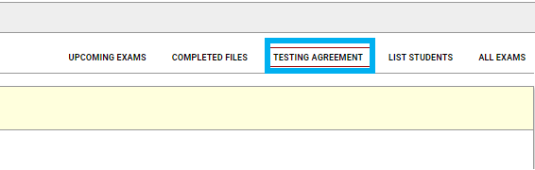

1. Find the course you are completing the testing agreement for and click “Specify Testing Agreement”.

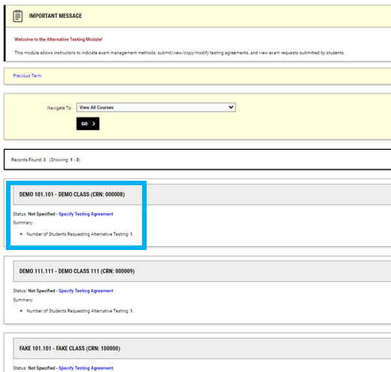

1. Under “Available Options”, choose an option from the dropdown menu. You will choose: “AEC will proctor exams” or "I will proctor my own exams”. If your class does not have exams, please choose “My class has no exam”. Next, click “Confirm to Proceed” and “Submit your selection” at the bottom of the screen.

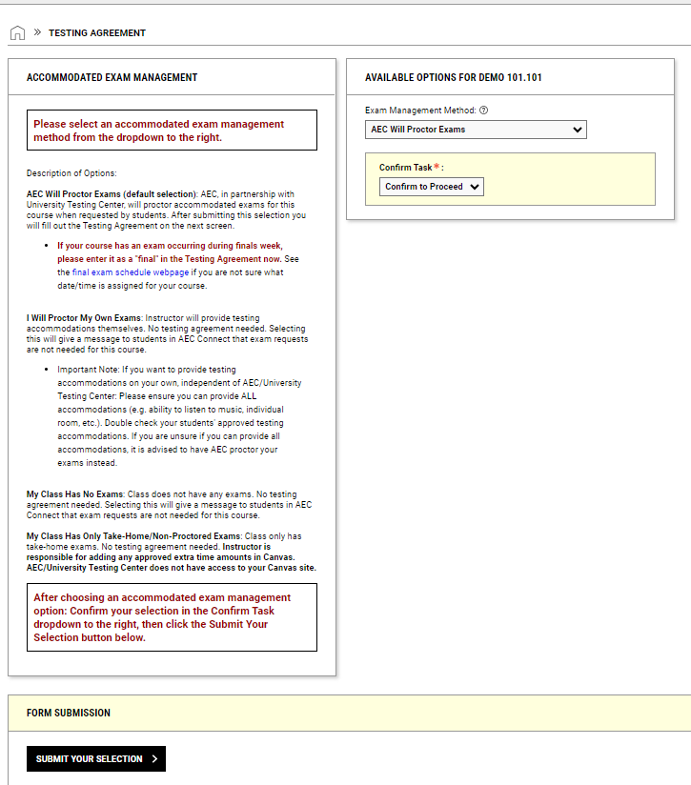

1. Complete the “List of Questions” and “Contact Information”.

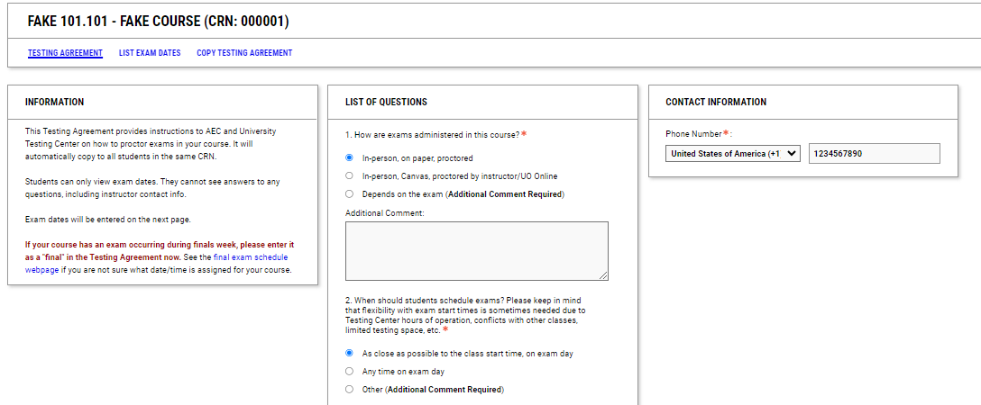

1. Scroll to the bottom of the page and click “Update and View Exam Dates”.

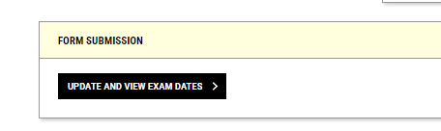

1. Fill in the exam details for all exams that will be given this term. After each individual exam, click “Save Exam Date”.

