# Instructions for Instructors

## How to modify a testing agreement

1. [Log in to AEC Connect](https://aec.uoregon.edu/content/using-aec-connect) with your DuckID and password. This will take you to your Dashboard.
2. Click “Continue to View Student Accommodations”.

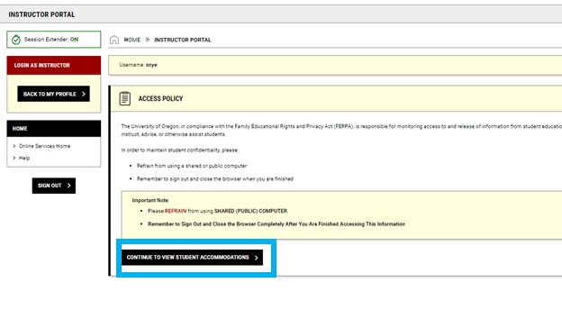

1. Next, click “Alternative Testing” on the left side of the screen.

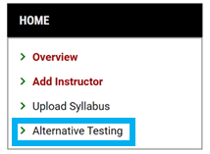

1. Click “Testing Agreement” at the top right of the screen.

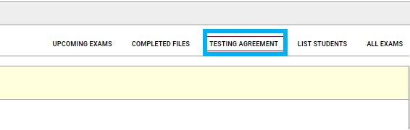

1. Find the course you are modifying the testing agreement for and click “View/ Modify Testing Agreement”.

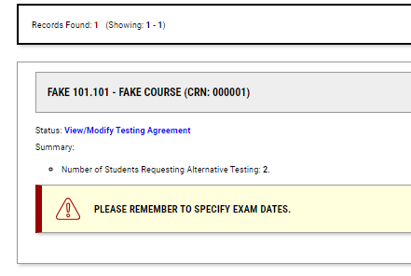

1. Now you can make any changes you would like to the testing agreement. If you are changing the testing agreement, remember to click “Update and View Exam Dates” when you are done.

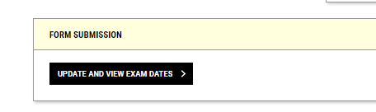

1. If you are adding or changing exam dates, make sure to click “Save Exam Date” when you are done.

