# Instructions for Instructors

## How upload an exam:

1. [Log in to AEC Connect](https://aec.uoregon.edu/content/using-aec-connect) with your DuckID and password. This will take you to your Dashboard.
2. Click “Continue to View Student Accommodations”.

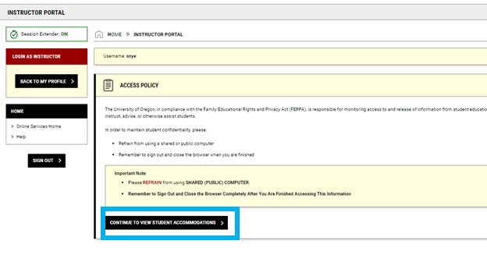

1. Next, click “Alternative Testing” on the left side of the screen.

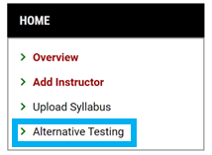

1. Click “Testing Agreement” at the top right of the screen.

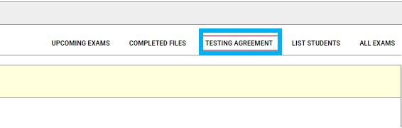

1. Find the course you are uploading the exam for and click “View/ Modify Testing Agreement”.

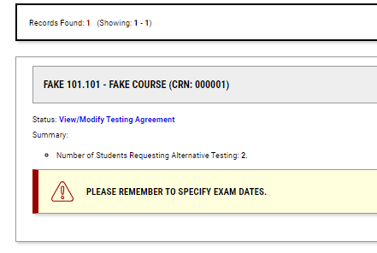

1. Next, click “List Exam Dates” under the course name.

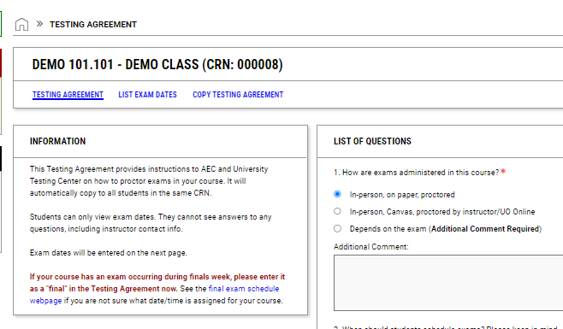

1. Under “List Exam Dates”, click “Modify” next to the exam date that you would like to upload the exam file to.

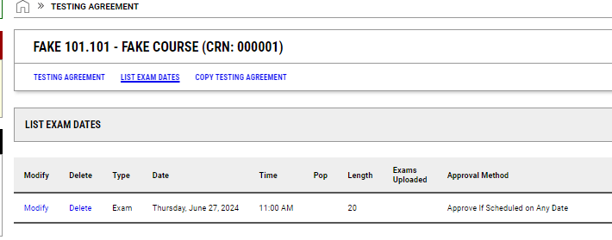

1. Please name your file and upload the exam file.

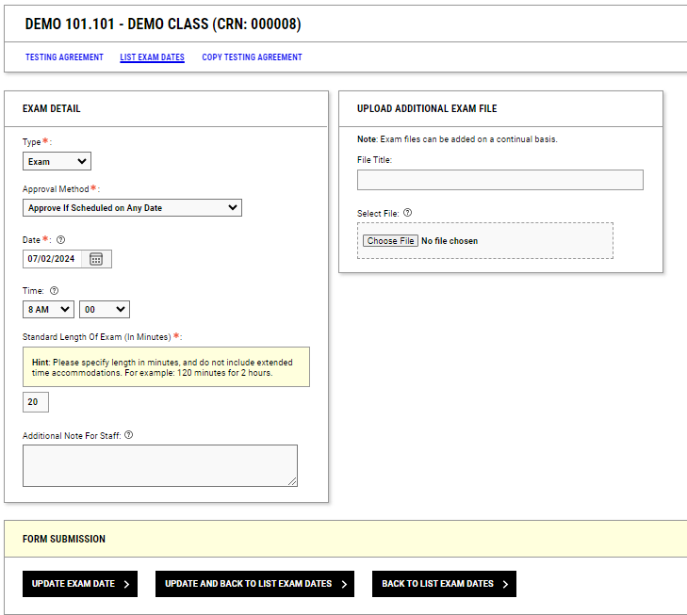

1. When you are done uploading, click “Update Exam Date” or “Update and Back to List Exam Dates” at the bottom of the screen.

