# Instructions for Instructors

## How to view a student’s accommodations:

1. [Log in to AEC Connect](https://aec.uoregon.edu/content/using-aec-connect) with your DuckID and password. This will take you to your Dashboard.
2. Click “Continue to View Student Accommodations”.

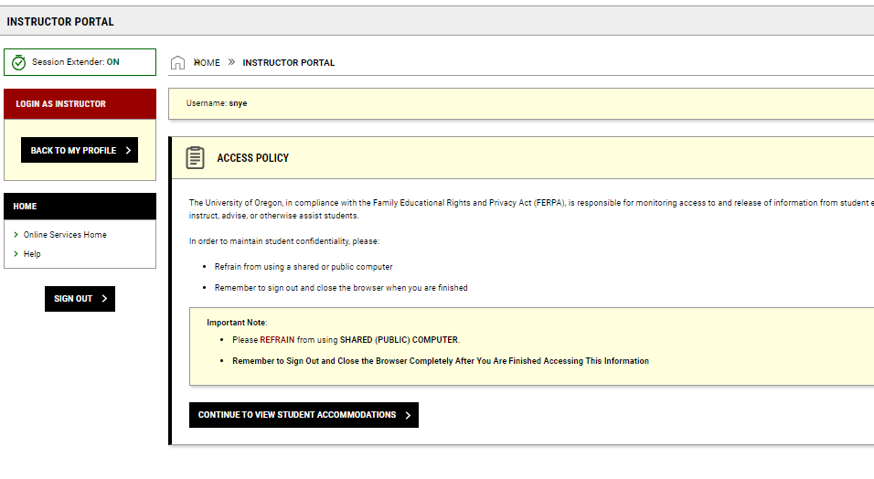

1. Find the section under “Students Who Requested Accommodations” that says: “Export Data: Students”.
2. Select “View” for each student.

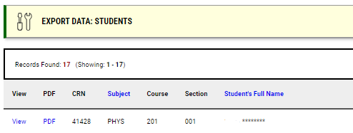

1. Here you will be able to view each student’s accommodations for the term.

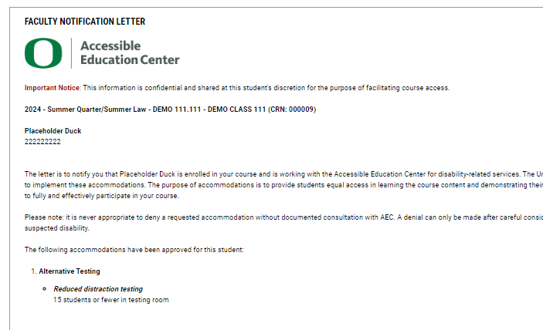

1. Instructors can also search through the list of students who have requested accommodations by clicking the “Refine Search” button under the “Students Who Requested Accommodations” section.

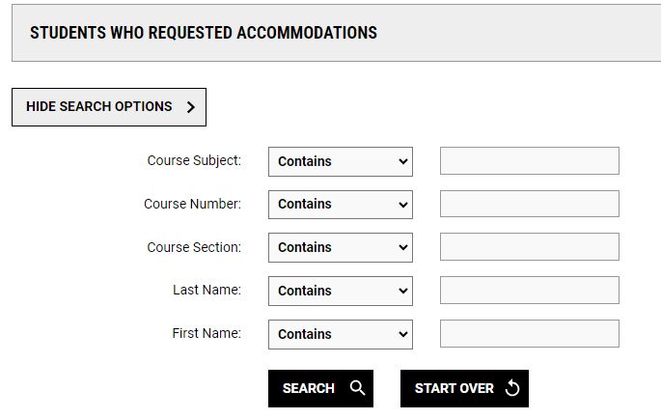

1. Lists can be exported to Excel by expanding the “Export Data: Students” tab. By default, all cancelled requests will be excluded but that can be changed via the dropdown.

