# Instructions for Students

### Requesting Alternative Materials:

The Accessible Education Center offers a service in which students can request that materials from their courses be converted into a more accessible format. The request is received by our Accessible Technology Department, who can then begin work on converting the materials. **It is important to note that this can be a lengthy process, so students are advised to submit their requests sooner rather than later. It should also be noted that if you require testing materials converted, please discuss with your instructor.**

1. [Log in to AEC Connect](https://aec.uoregon.edu/using-aec-connect) with your DuckID and password. This will take you to your Dashboard.
2. Find the box titled “Accommodations” on the left side of the page.
3. Click "Alternative Formats".

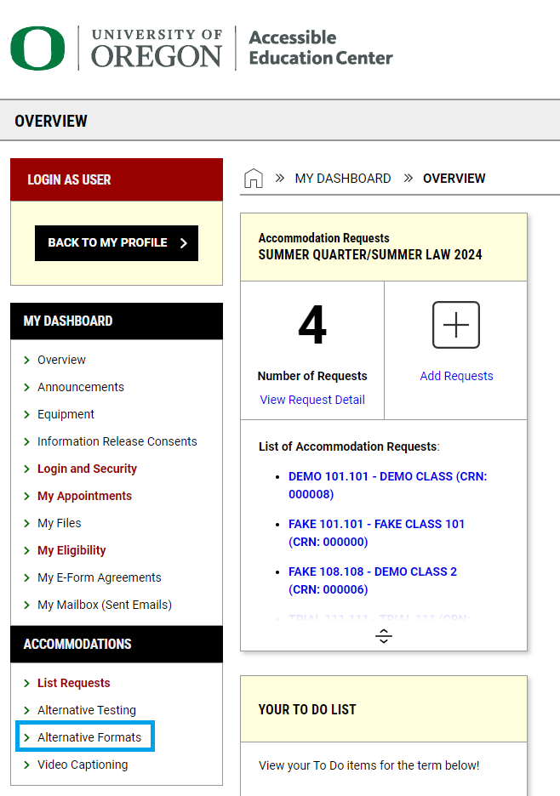

1. In the top right corner, click on "Requests".

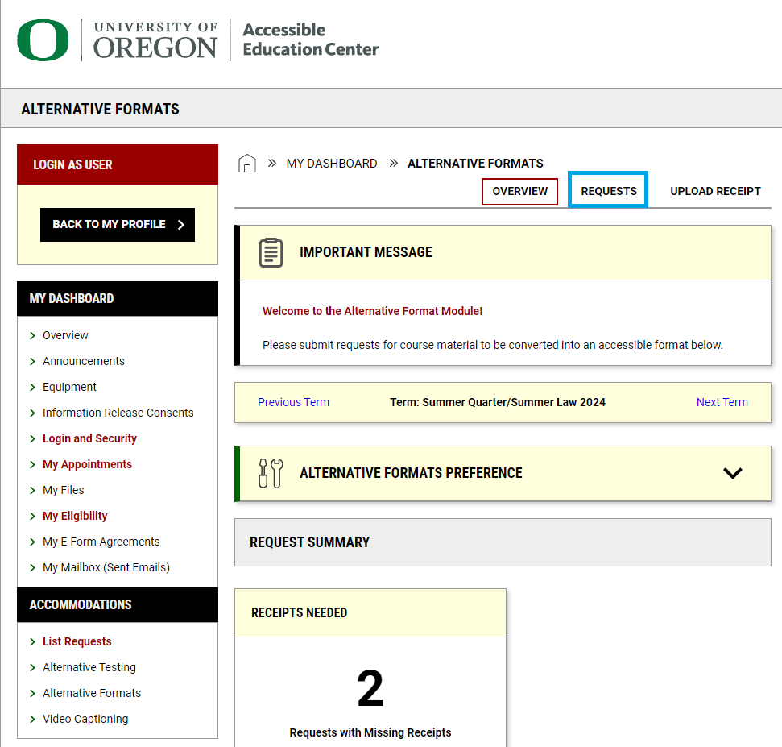

1. Scroll down until you find a box labeled "Reading Materials"

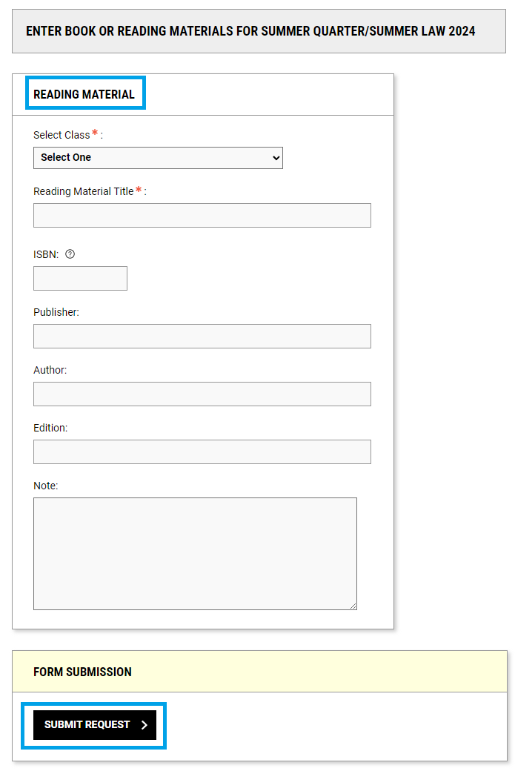

1. Select the class from the drop-down menu, and add the Reading Material title, ISBN (If applicable), Publisher (if applicable), Author (if applicable), Edition (if applicable), and any Notes.
2. Hit 'Upload Document' in the 'Form Submission' box below.
3. If you submitted a book that you purchased, return to the Alternative Format Page. In the top right corner, click on "Upload Receipt".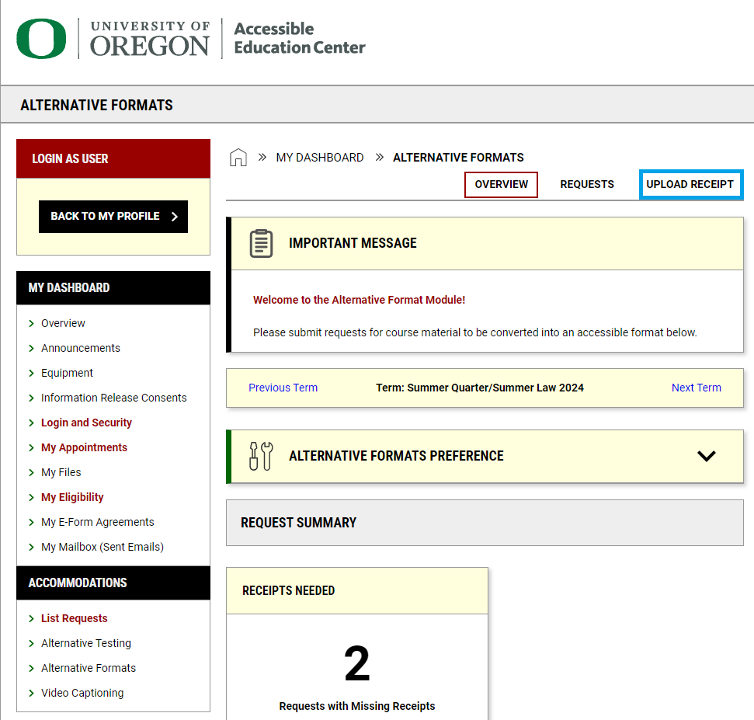
4. Scroll down until you see a box labeled "Receipt Detail".

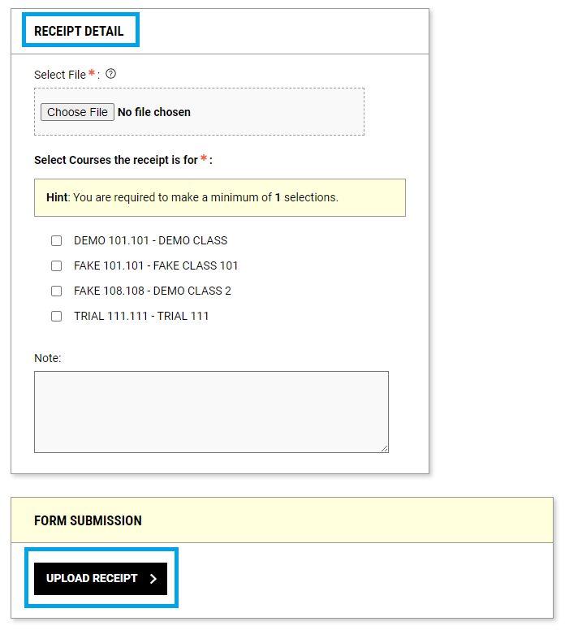

1. Upload the receipt, select which class the receipt is for, and hit submit.