# Instructions for Students

## How to modify and resend notification letters

1. Log in to [AEC Connect](https://aec.uoregon.edu/node/30) with your DuckID and password. This will take you to your Dashboard. Find the box titled “Accommodation Requests” and select “View Request Detail”.

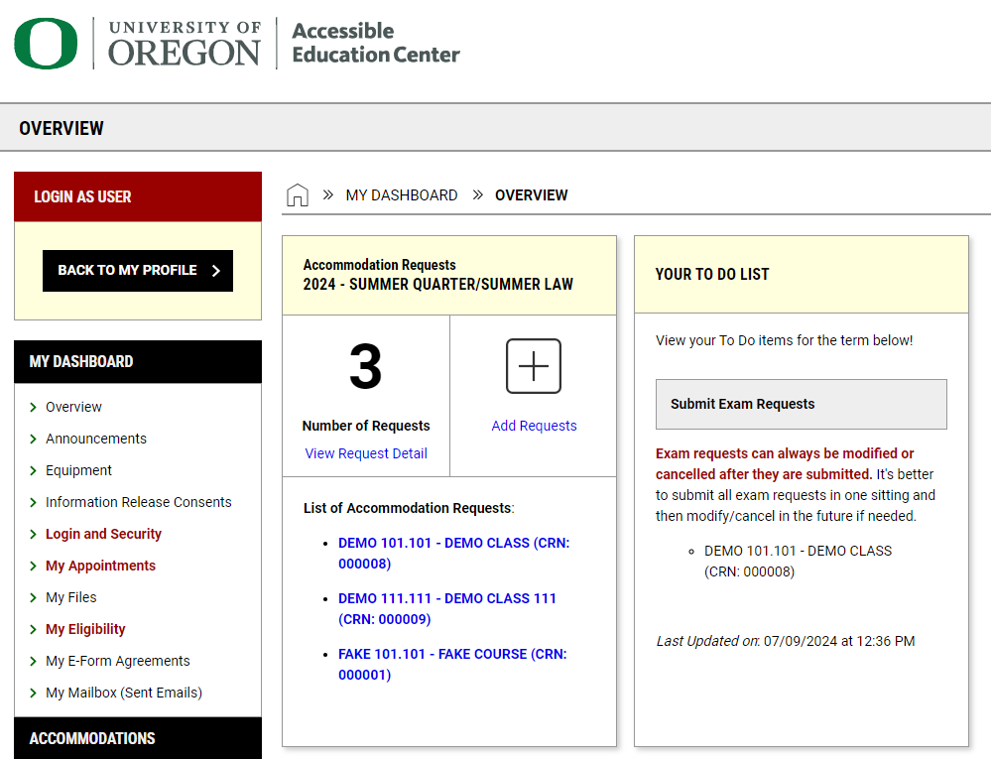

1. This will take you to the “Accommodations Requests” page. Find the course you would like to modify the notification letter for and select “Modify Request”.

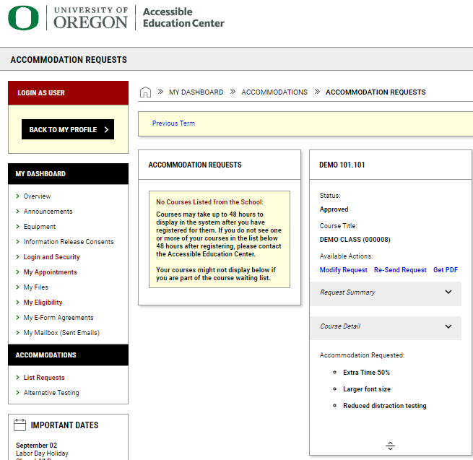

1. Next, find the box titled “Select Accommodations” and select the new accommodations you would like to utilize for this course.

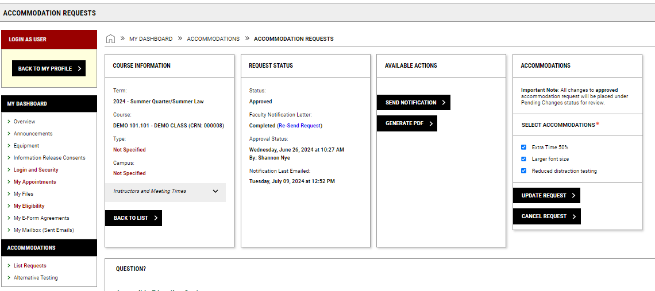

1. Once you have selected your new accommodations, click “Update Request”.

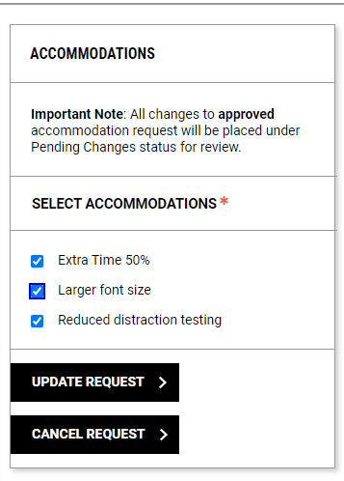

1. Once you are done, you will see a notification at the top of the screen that says, “Success! Your action has been completed.”

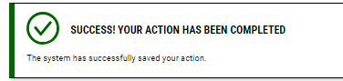

1. Your request will be reviewed and approved by AEC staff within the next business day. Once approved, the instructor of the class will receive an updated notification letter and you will also receive an emailed copy.