# Instructions for Students

## Sending Notification Letters:

A notification letter is the official communication to faculty outlining the appropriate accommodations established for an individual student. Notification letters must be sent in order for students to utilize their accommodations. Therefore, **students are encouraged to send notification letters during the first week of the term.** To view your established accommodations, log in to [AEC Connect](https://aec.uoregon.edu/using-aec-connect) and click "My Eligibility" on the left toolbar.

1. [Log in to AEC Connect](https://aec.uoregon.edu/content/using-aec-connect) with your DuckID and password. This will take you to your Dashboard.
2. Find the box titled “Your To Do List”.
3. Click “Request Accommodations”.

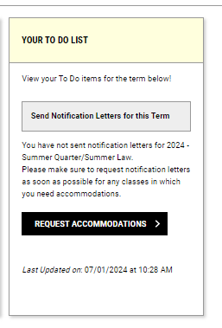

1. Check the box next to each class you’d like to use accommodations in and click “Apply the **same accommodations** to all selected courses” if you would like to utilize the same accommodations for all classes. Next, click “Continue to Next Step”.

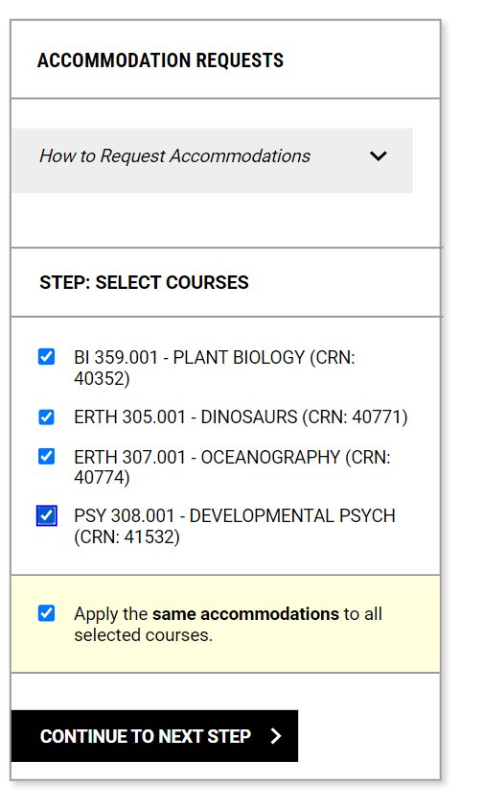

1. Select the accommodations you’d like to use for each class and click “Submit Requests”.

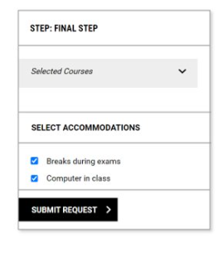

1. Make sure that total “Number of Requests” appears above “View Request Detail”.

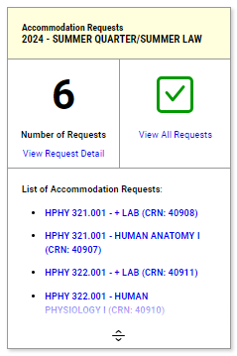

1. Notification letters are automatically sent out through AEC Connect after requests are submitted, as long as an instructor of record is listed for the class in DuckWeb.