# Instructions for Students

## Submitting Exam Requests:

Exam requests are submitted in AEC Connect for each exam that students want to take in the testing center to receive their accommodations. AEC works with the University Testing Center, located in Knight Library 31, to administer accommodation exams. **Students are encouraged to submit exam requests ASAP each term.** You can always modify or cancel a request later.

1. [Log in to AEC Connect](https://aec.uoregon.edu/content/using-aec-connect) with your DuckID and password. This will take you to your Dashboard.
2. Under “Accommodations” on the left side of the screen, select “Alternative Testing”.

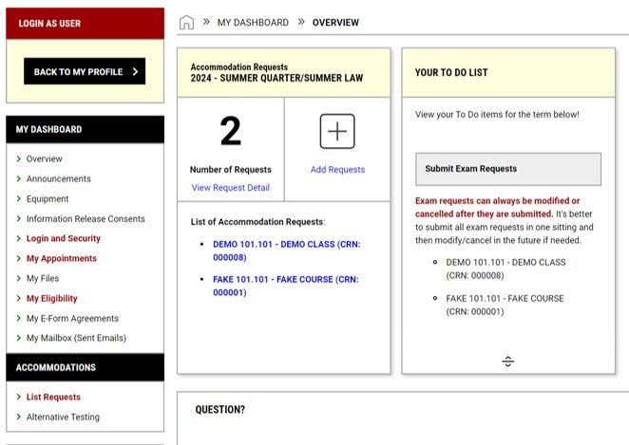

1. Under “Schedule an Exam”, click the dropdown menu next to “Select Course”.
   * If your class is not listed, your instructor hasn’t submitted a testing agreement yet. Email [aectesting@uoregon.edu](mailto:aectesting@uoregon.edu) to let us know and we will follow up with your instructor.
2. Select the appropriate class and click “Schedule an Exam”

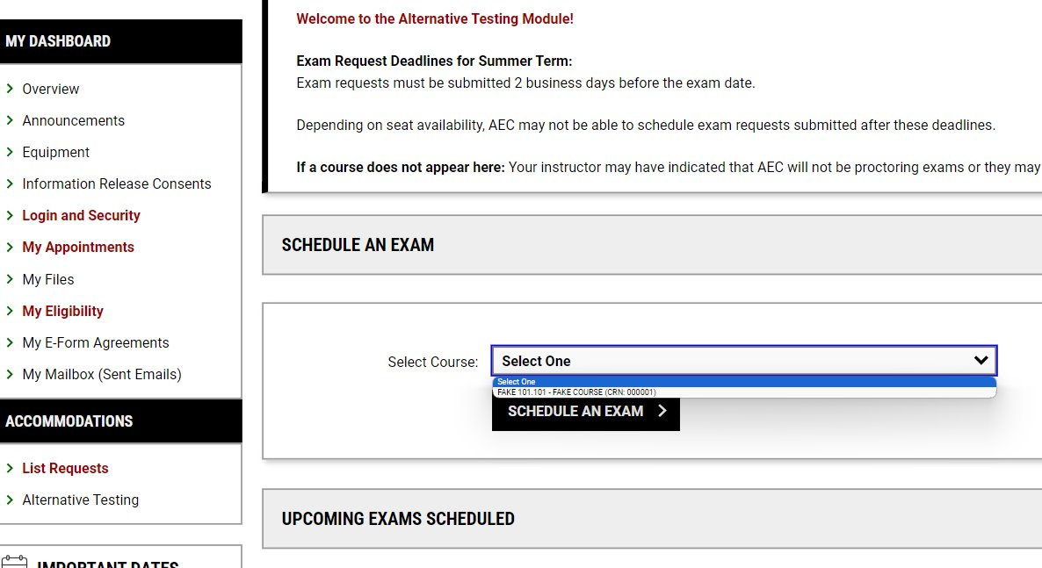

1. Review the Terms and Conditions of Exam Scheduling information.

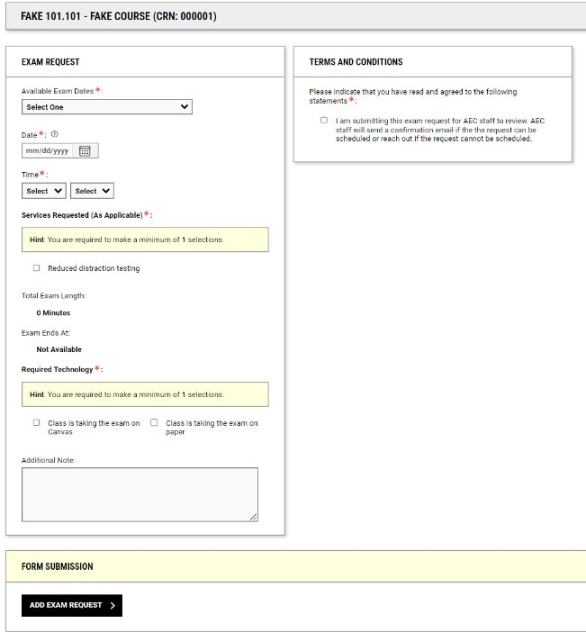

1. Under “Exam Request”, select the exam date, enter your requested exam start time, and check the boxes for the accommodations you would like to use. Last, check whether the exam is on Canvas or paper. Click “Add Exam Request” under “Form Submission”. **Exams should typically be scheduled at the same time as the class. You will generally need instructor approval to schedule the exam at a different time.**



1. For exam requests that are submitted late (within 7 days of the exam for weeks 1-10 and after Friday of week 8 for finals), students must enter a late exam request reason **before**the request will go through.