# Instructions for Students

## To Double Check, Modify, or Cancel an Exam Request:

1. Log in to [AEC Connect](https://aec.uoregon.edu/node/30) with your DuckID and password. Under “Accommodations” on the left side of the screen, select “Alternative Testing”.

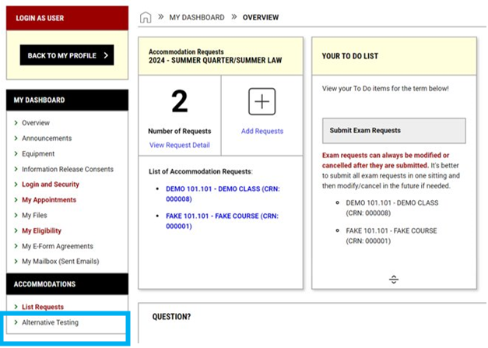

1. All submitted exam requests will appear under “Upcoming Exams Scheduled” for the Current Term.

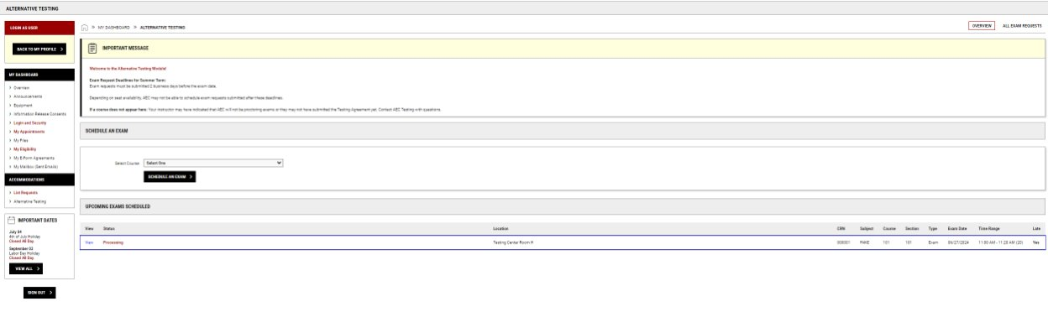

1. Click “View” next to the exam request if you would like to double check, modify, or cancel your request.

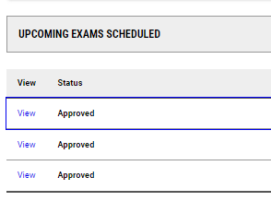

1. To Modify- Make any changes you need and click “Update Exam Requests”.

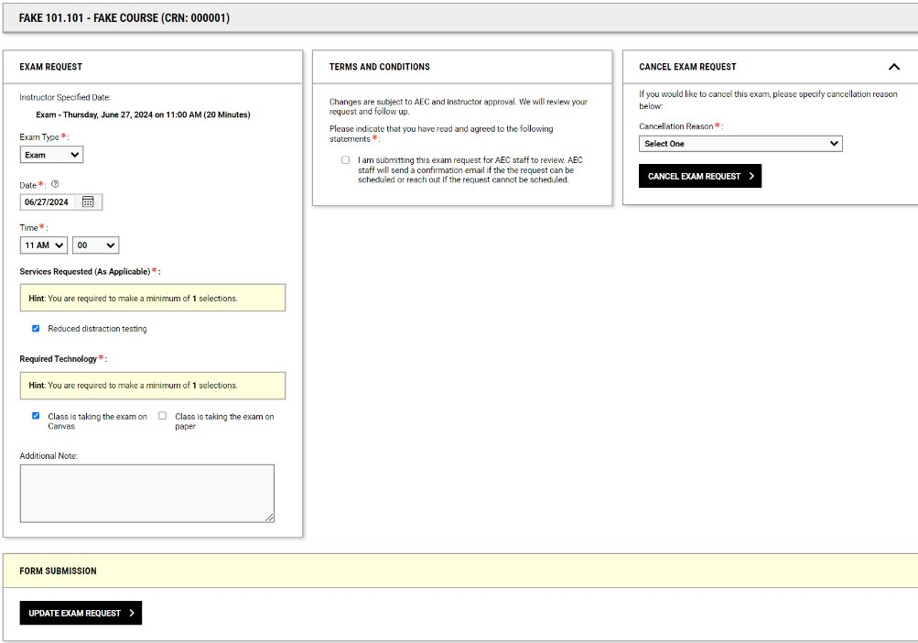

1. To Cancel- Select a cancellation reason and click “Cancel Exam Request”.

